**QMS-INTEACTIVE-AI (BOM)**

**ACTIONABL INSTALLATION GUIDE**

**Requirements:**

**Step 1**:

Whitelist URL ‘s to install node and chocolatey packages in your System.

* <https://nodejs.org/en/>
* https://dotnet.microsoft.com/en-us/download/dotnet/6.0/runtime
* https://www.python.org/downloads/
* https://www.postgresqlorg/
* https://dbeaver.io/
* https://slproweb.com/products/win32OpenSSL.html
* https://*.npmjs.com/*
* https://pypi.org
* https://pythonhosted.org
* https://files.pythonhosted.org
* https://huggingface.co
* https://huggingface.co/api/*
* https://huggingface.co/models/*
* https//*.huggingface.co/*
* https://*.github.com/*
* [https://*.nuget.org/*](https://*.nuget.org/*)
* <https://chocolatey.org/>
* https://yarnpkg.com/
* <https://registry.npmpkg.com/>

**Step 2**:

Apply For PowerShell Access to Install Postgres SQL and Chocolatey on your System.

**Step 3**:

Apply For Port Opening for Actionabl server and interactive ai server

* Actionabl (3002, 2999)
* Label Studio (8080)
* ML Backend (9090)
* HTTPS (2443, 5080)

**Step 4**:

Push All the Required Files to Server or Copy All the Files to the Server. Such as

* Actionabl Build files and Process Files.
* VSCodeUserSetup-x64-1.99.3.exe
* Feat-Interactive-AI-Api-Release-main.zip
* label-studio-interactive-latest-main.zip
* label-studio-interactive-main.zip
* label-studio-ml-backend-interactive--main.zip
* label-studio-sdk-master.zip
* label-studio-ml-backend-master.zip
* python-3.12.4-amd64.exe
* Win64OpenSSL-3_4_1.msi
* Dbeaver-ce-25.0.3-x86_64-setup.exe
* Node-v22.15.0-x64.msi
* Postgresql-17.4.1-windows-x64.exe
* vs_BuildTools.exe
* dotnet-sdk-8.0.408-win-x86.exe
* aspnetcore-runtime-8.0.15-win-x86.exe
* windowsdesktop-runtime-8.0.15-win-x86.exe
* VC-redist.x86.exe

**Step 5**:

Apply for Microsoft 365 mail Access.

**Step 6:**

Proxy Server Details And Port No. and set proxy.

* <https://10.128.106.4:8080>
* <https://10.128.106.5:8080>.
* setx HTTP_PROXY <https://10.128.106.4:8080>
* setx HTTPS_PROXY <https://10.128.106.4:8080>

**Installation:**

1. Whitelist all URL’s in step 1. (Mandatory)
2. Get Powershell Access to install chocolatey and postresql mentioned in step 2. (Mandatory)
3. Install Nodejs using step 4. and select additional tools chocolatey and install.
4. Install Postgresql using step 4. and after installation ,set below configuration.
   1. Server[localhost]
   2. Database[postgres]
   3. Port[5432]
   4. Username[postgres]
   5. Password[feat@1234]
5. Install Visual Studio Code using step 4.
6. Unzip Actionabl Folder.
7. Open “\Actionabl\App\Setup” folder and open setDatabase.bat file as run as administrator and set database and set admin as user and feat@1234 as password and actionabl as database.
8. Open setCredential.bat file as run as administrator and set database credentials feat@1234
9. Open “\Actionabl” folder App.code-workspace file.
10. VS Code will open and project files will be visible.
11. Create new project and set active_project: true.

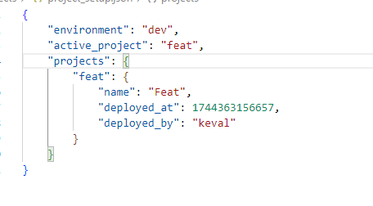

1. Copy all the config files from the existing project and paste in “Actionabl\Projects\Feat\Folders\Resources\Published\Config” folder.

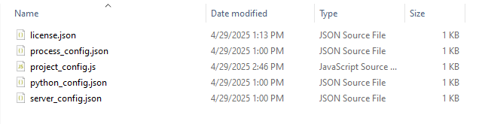

1. Open project.config and configure the database and cluster settings.

In db_setup Set run_setup:true, and recreate:true;

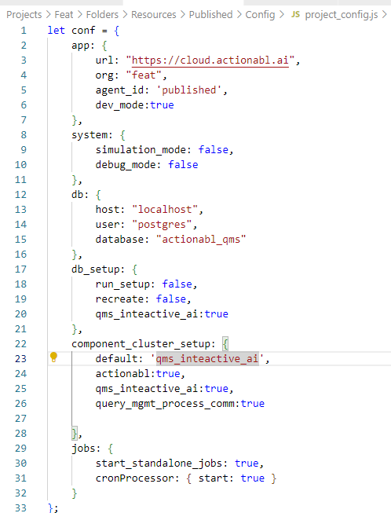

1. Open new terminal in “\Actionabl\App\Server” and run npm i
2. Open new terminal in “\Actionabl\Projects” and run npm i
3. Go to debug option and click on launch.json and edit the http_port : 3002. Save and close.
4. Click on debug and start the server.

Open project.config file and in db_setup, Set run_setup:true, and recreate:true;

1. Restart server.
2. Login as Admin.

**Interactive-Ai-Label Studio Installation Guide**

**Installation:**